### **Step 1: Installing Prerequisites and Examine Drives**

**1.** As I said above, we’re using mdadm utility for creating and managing RAID in Linux. So, let’s install the **mdadm** software package on Linux using yum or apt-get package manager tool.

# yum install mdadm [on RedHat systems]

# apt-get install mdadm [on Debain systems]

**2.** Once ‘**mdadm**‘ package has been installed, we need to examine our disk drives whether there is already any raid configured using the following command.

# mdadm -E /dev/sd[b-c]

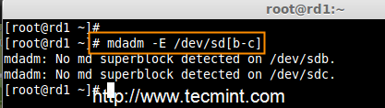

Check RAID on Disks

As you see from the above screen, that there is no any **super-block** detected yet, means no RAID defined.

### **Step 2: Drive Partitioning for RAID**

**3.** As I mentioned above, that we’re using minimum two partitions **/dev/sdb** and **/dev/sdc** for creating RAID1. Let’s create partitions on these two drives using ‘**fdisk**‘ command and change the type to raid during partition creation.

# fdisk /dev/sdb

###### **Follow the below instructions**

1. Press ‘**n**‘ for creating new partition.
2. Then choose ‘**P**‘ for Primary partition.
3. Next select the partition number as **1**.
4. Give the default full size by just pressing two times **Enter** key.
5. Next press ‘**p**‘ to print the defined partition.
6. Press ‘**L**‘ to list all available types.
7. Type ‘**t**‘to choose the partitions.
8. Choose ‘**fd**‘ for Linux raid auto and press Enter to apply.
9. Then again use ‘**p**‘ to print the changes what we have made.
10. Use ‘**w**‘ to write the changes.

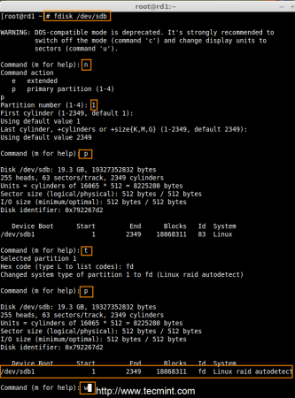

Create Disk Partitions

After ‘**/dev/sdb**‘ partition has been created, next follow the same instructions to create new partition on **/dev/sdc** drive.

# fdisk /dev/sdc

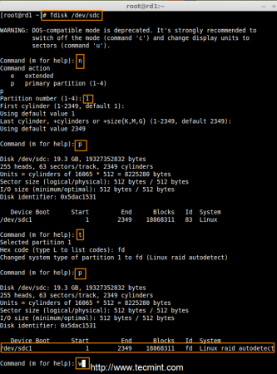

Create Second Partitions

**4.** Once both the partitions are created successfully, verify the changes on both **sdb** & **sdc** drive using the same ‘**mdadm**‘ command and also confirm the RAID type as shown in the following screen grabs.

# mdadm -E /dev/sd[b-c]

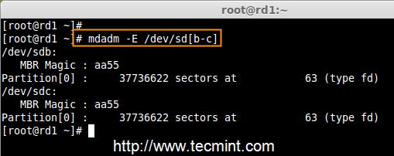

Verify Partitions Changes

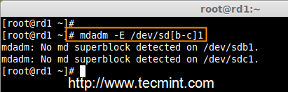

Check RAID Type

**Note**: As you see in the above picture, there is no any defined RAID on the **sdb1** and **sdc1** drives so far, that’s the reason we are getting as no **super-blocks** detected.

### **Step 3: Creating RAID1 Devices**

**5.** Next create RAID1 Device called ‘**/dev/md0**‘ using the following command and verity it.

# mdadm --create /dev/md0 --level=mirror --raid-devices=2 /dev/sd[b-c]1

# cat /proc/mdstat

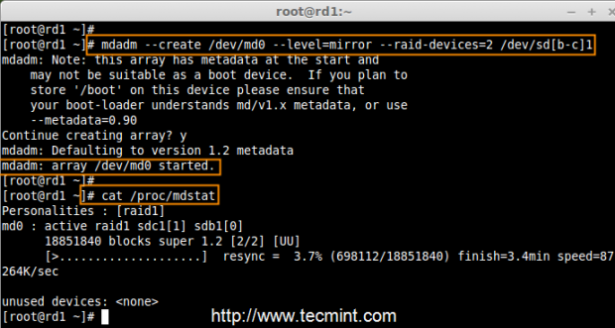

Create RAID Device

**6.** Next check the raid devices type and raid array using following commands.

# mdadm -E /dev/sd[b-c]1

# mdadm --detail /dev/md0

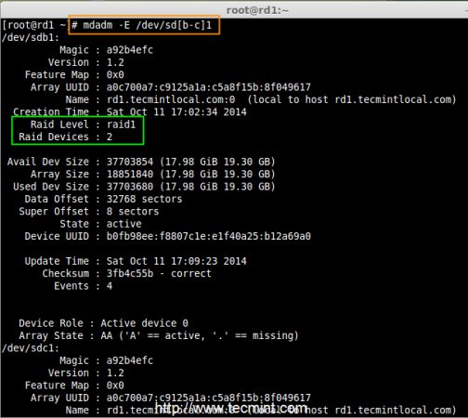

Check RAID Device type

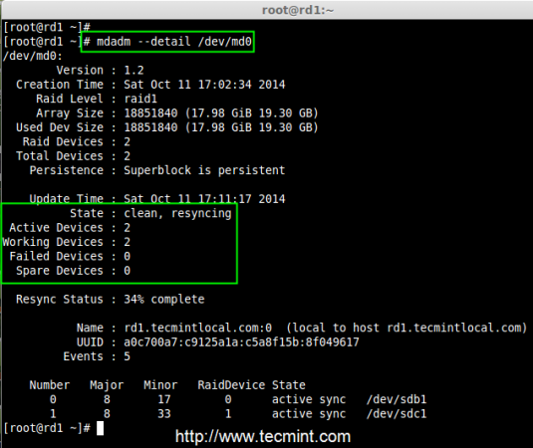

Check RAID Device Array

From the above pictures, one can easily understand that raid1 have been created and using **/dev/sdb1** and **/dev/sdc1** partitions and also you can see the status as resyncing.

### **Step 4: Creating File System on RAID Device**

**7.** Create file system using ext4 for **md0** and mount under **/mnt/raid1**.

# mkfs.ext4 /dev/md0

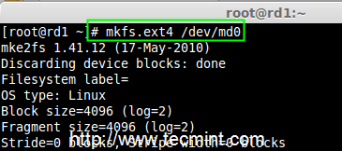

Create RAID Device Filesystem

**8.** Next, mount the newly created filesystem under ‘**/mnt/raid1**‘ and create some files and verify the contents under mount point.

# mkdir /mnt/raid1

# mount /dev/md0 /mnt/raid1/

# touch /mnt/raid1/tecmint.txt

# echo "tecmint raid setups" > /mnt/raid1/tecmint.txt

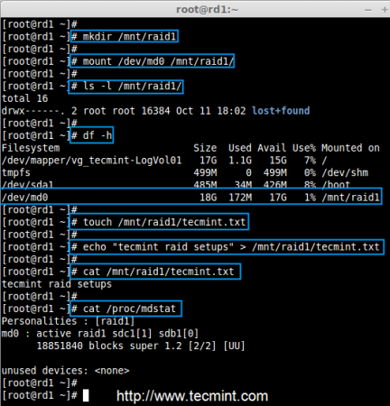

Mount Raid Device

**9.** To auto-mount RAID1 on system reboot, you need to make an entry in fstab file. Open ‘**/etc/fstab**‘ file and add the following line at the bottom of the file.

/dev/md0 /mnt/raid1 ext4 defaults 0 0

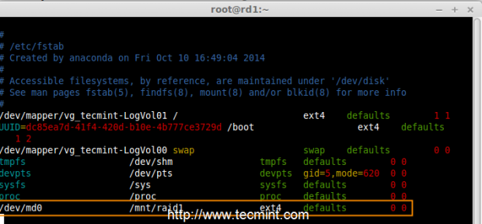

Raid Automount Device

**10.** Run ‘**mount -a**‘ to check whether there are any errors in fstab entry.

# mount -av

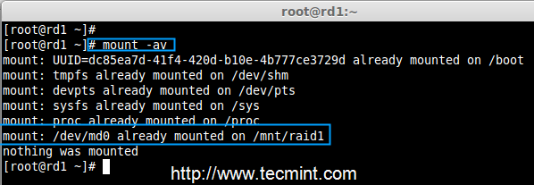

Check Errors in fstab

**11.** Next, save the raid configuration manually to ‘**mdadm.conf**‘ file using the below command.

# mdadm --detail --scan --verbose >> /etc/mdadm.conf

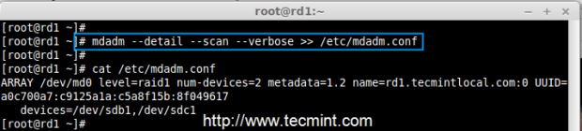

Save Raid Configuration

The above configuration file is read by the system at the reboots and load the RAID devices.

### **Step 5: Verify Data After Disk Failure**

**12.** Our main purpose is, even after any of hard disk fail or crash our data needs to be available. Let’s see what will happen when any of disk disk is unavailable in array.

# mdadm --detail /dev/md0

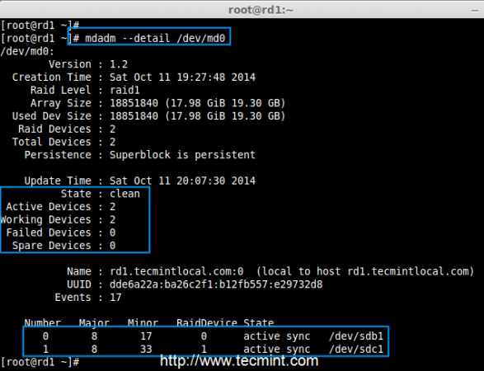

Raid Device Verify

In the above image, we can see there are 2 devices available in our RAID and Active Devices are 2. Now let us see what will happen when a disk plugged out (removed **sdc** disk) or fails.

# ls -l /dev | grep sd

# mdadm --detail /dev/md0

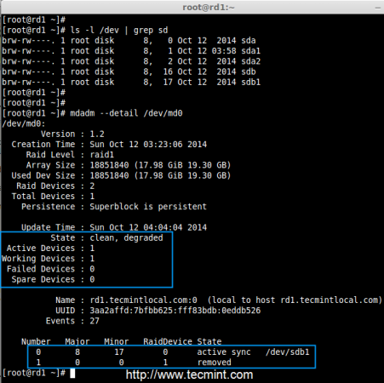

Test RAID Devices

Now in the above image, you can see that one of our drive is lost. I unplugged one of the drive from my Virtual machine. Now let us check our precious data.

# cd /mnt/raid1/

# cat tecmint.txt

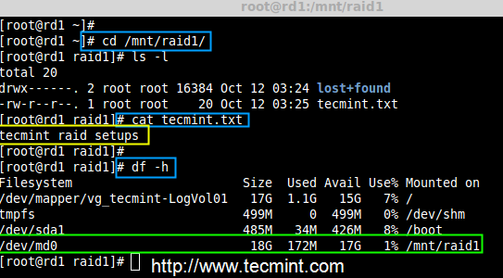

Verify RAID Data

Did you see our data is still available. From this we come to know the advantage of RAID 1 (mirror).